**AVALIAÇÃO INDIVIDUAL**

Lucas Azevedo Dias

1. Primeira questão:
   1. Resposta:

|  |  |  |  |  |  |  |  |  |  |  |
| --- | --- | --- | --- | --- | --- | --- | --- | --- | --- | --- |
| A | B | C | D | LED A | LED B | LED C | LED D | LED E | LED F | LED G |
| 0 | 0 | 0 | 0 | 1 | 1 | 1 | 1 | 1 | 1 | 0 |
| 0 | 0 | 0 | 1 | 0 | 1 | 1 | 0 | 0 | 0 | 0 |
| 0 | 0 | 1 | 0 | 1 | 1 | 0 | 1 | 1 | 0 | 1 |
| 0 | 0 | 1 | 1 | 1 | 1 | 1 | 1 | 0 | 0 | 1 |
| 0 | 1 | 0 | 0 | 0 | 1 | 1 | 0 | 0 | 1 | 1 |
| 0 | 1 | 0 | 1 | 1 | 0 | 1 | 1 | 0 | 1 | 1 |
| 0 | 1 | 1 | 0 | 1 | 0 | 1 | 1 | 1 | 1 | 1 |
| 0 | 1 | 1 | 1 | 1 | 1 | 1 | 0 | 0 | 0 | 0 |
| 1 | 0 | 0 | 0 | 1 | 1 | 1 | 1 | 1 | 1 | 1 |
| 1 | 0 | 0 | 1 | 1 | 1 | 1 | 1 | 0 | 1 | 1 |
| 1 | 0 | 1 | 0 | 1 | 1 | 1 | 0 | 1 | 1 | 1 |
| 1 | 0 | 1 | 1 | 0 | 0 | 1 | 1 | 1 | 1 | 1 |
| 1 | 1 | 0 | 0 | 1 | 0 | 0 | 1 | 1 | 1 | 0 |
| 1 | 1 | 0 | 1 | 0 | 1 | 1 | 1 | 1 | 0 | 1 |
| 1 | 1 | 1 | 0 | 1 | 0 | 0 | 1 | 1 | 1 | 1 |
| 1 | 1 | 1 | 1 | 1 | 0 | 0 | 0 | 1 | 1 | 1 |

*Obs.: Está resolvido também através do programa em <https://replit.com/@FunNyLuAz/Trabalho-8-Mapas-de-Karnaugh>.

* 1. Resposta:
* LED A

|  |  |  |  |  |
| --- | --- | --- | --- | --- |
| ABCD | 00 | 01 | 11 | 10 |
| 00 | 1 |  | 1 | 1 |
| 01 |  | 1 | 1 | 1 |
| 11 | 1 |  | 1 | 1 |
| 10 | 1 | 1 |  | 1 |

$$A^{'}B^{'}D^{'}+A^{'}C+A^{'}BD+BC+AD^{'}+AB^{'}C^{'}$$

$${∴A}^{'}⋅\left(B^{'}D^{'}+C+BD\right)+BC+AD^{'}+AB'C'$$

* LED B

|  |  |  |  |  |
| --- | --- | --- | --- | --- |
| ABCD | 00 | 01 | 11 | 10 |
| 00 | 1 | 1 | 1 | 1 |
| 01 | 1 |  | 1 |  |
| 11 |  | 1 |  |  |
| 10 | 1 | 1 |  | 1 |

$$B^{'}C^{'}+A^{'}B'C'+AC'D+A^{'}C'D'+A'CD+A'B'C+AB^{'}D^{'}$$

$$B^{'}C^{'}⋅(1+A')+AC'D+A^{'}C'D'+A'CD+A'B'C+AB^{'}D^{'}$$

$$∴B^{'}C^{'}+AC'D+A'⋅(C'D'+CD)+B'⋅(A'C+AD^{'})$$

* LED C

|  |  |  |  |  |
| --- | --- | --- | --- | --- |
| ABCD | 00 | 01 | 11 | 10 |
| 00 | 1 | 1 | 1 |  |
| 01 | 1 | 1 | 1 | 1 |
| 11 |  | 1 |  |  |
| 10 | 1 | 1 | 1 | 1 |

$$A^{'}C^{'}+A'D+A^{'}BC+B'C'+AB'C+BC'D$$

$${∴A}^{'}⋅\left(C^{'}+D+BC\right)+B'⋅\left(C^{'}+AC\right)+BC'D$$

* LED D

|  |  |  |  |  |
| --- | --- | --- | --- | --- |
| ABCD | 00 | 01 | 11 | 10 |
| 00 | 1 |  | 1 | 1 |
| 01 |  | 1 |  | 1 |
| 11 | 1 | 1 |  | 1 |
| 10 | 1 | 1 | 1 |  |

$$AC^{'}+A^{'}B^{'}D^{'}+BCD^{'}+BC^{'}D+B'CD$$

$${∴AC^{'}+D}^{'}⋅\left(A'B'+BC\right)+D⋅\left(BC'+B'C\right)$$

* LED E

|  |  |  |  |  |
| --- | --- | --- | --- | --- |
| ABCD | 00 | 01 | 11 | 10 |
| 00 | 1 |  |  | 1 |
| 01 |  |  |  | 1 |
| 11 | 1 | 1 | 1 | 1 |
| 10 | 1 |  | 1 | 1 |

$$AC+ABC'+A^{'}CD^{'}+B^{'}C^{'}D^{'}$$

$$∴A⋅\left(C+BC^{'}\right)+D'⋅\left(A'C+B'C'\right)$$

* LED F

|  |  |  |  |  |
| --- | --- | --- | --- | --- |
| ABCD | 00 | 01 | 11 | 10 |
| 00 | 1 |  |  |  |
| 01 | 1 | 1 |  | 1 |
| 11 | 1 |  | 1 | 1 |
| 10 | 1 | 1 | 1 | 1 |

$$AC+AB^{'}C^{'}+A^{'}C^{'}D^{'}+BC'D'+A^{'}BC^{'}+A^{'}BD^{'}$$

$$∴A⋅(C+B^{'}C^{'})+C'D'⋅\left(A^{'}+B\right)+A'B⋅\left(C'+D'\right)$$

* LED G

|  |  |  |  |  |
| --- | --- | --- | --- | --- |
| ABCD | 00 | 01 | 11 | 10 |
| 00 |  |  | 1 | 1 |
| 01 | 1 | 1 |  | 1 |
| 11 |  | 1 | 1 | 1 |
| 10 | 1 | 1 | 1 | 1 |

* 1. Resposta:
* LED A

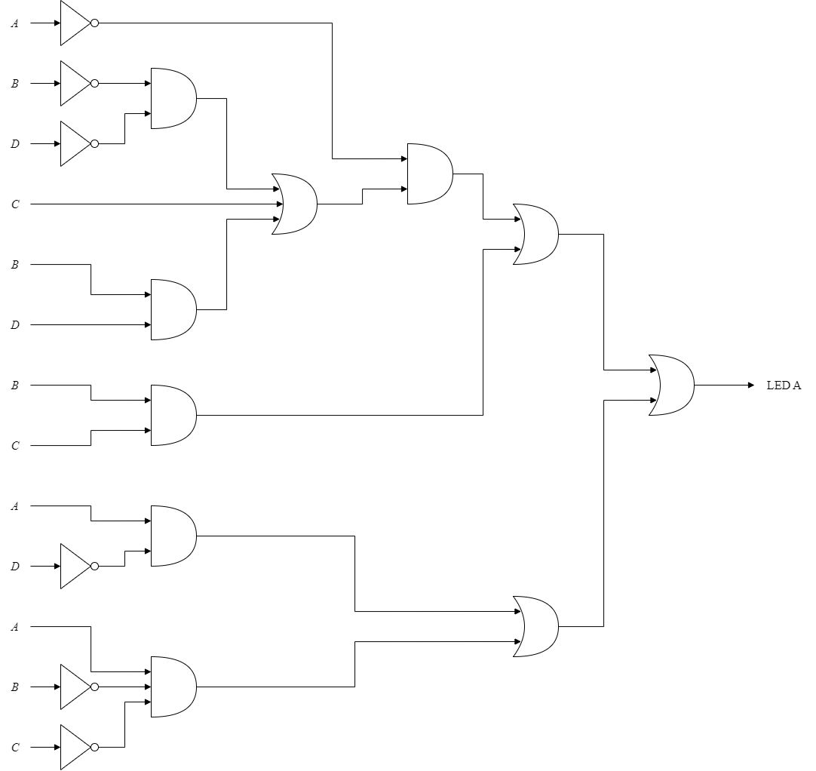

* LED B

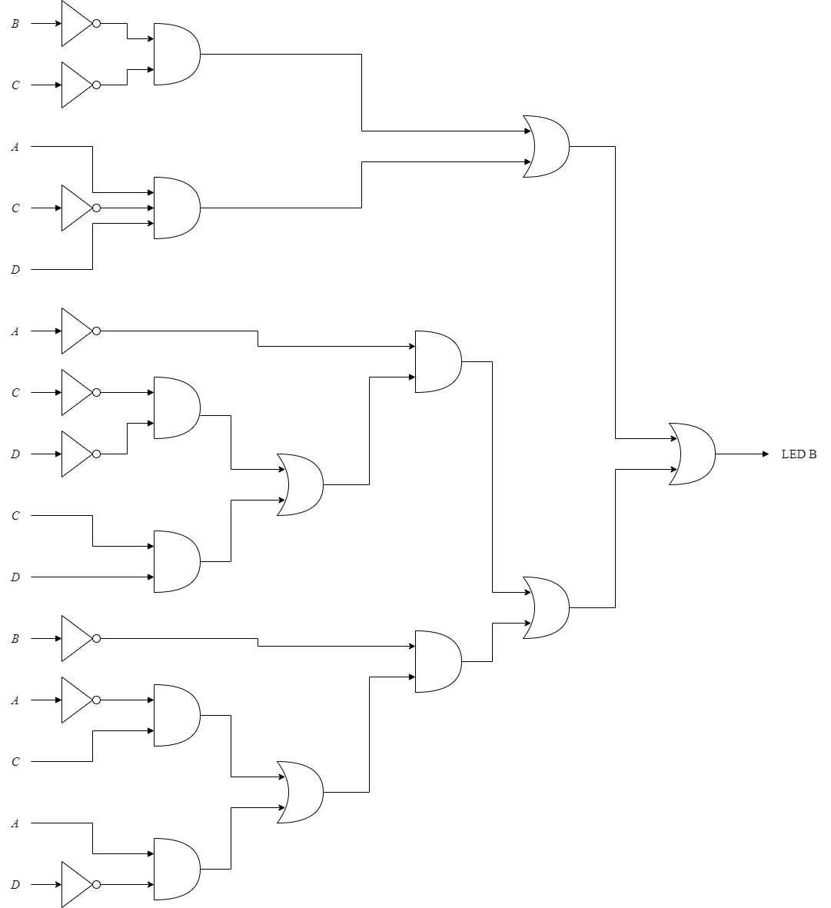

* LED C

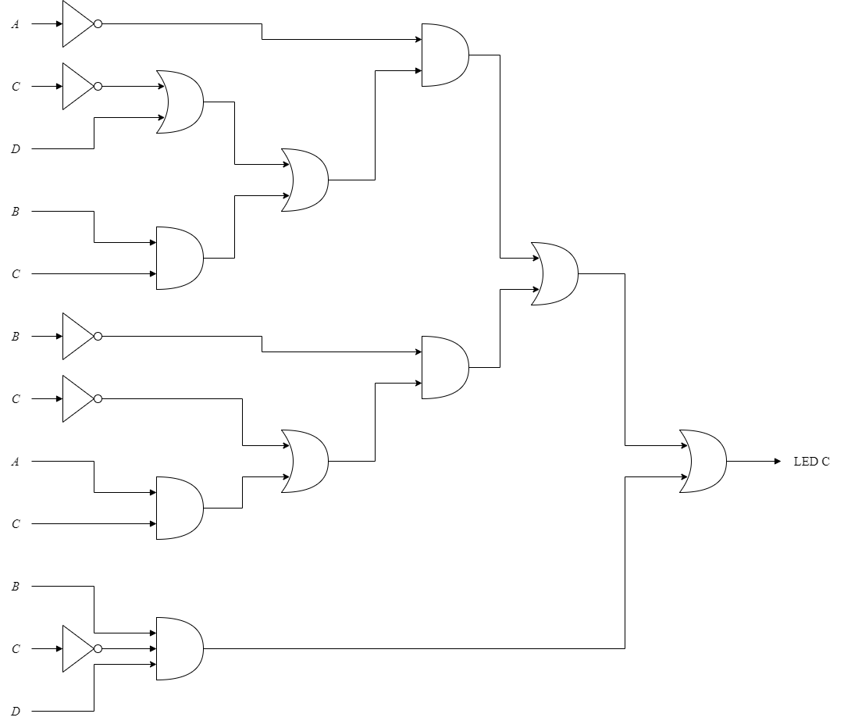

* LED D

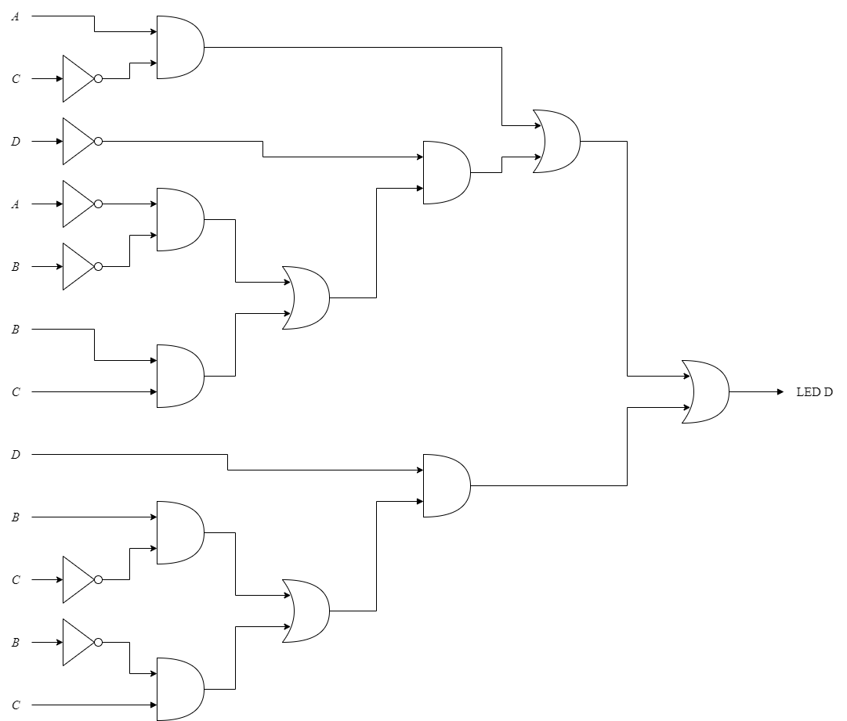

* LED E

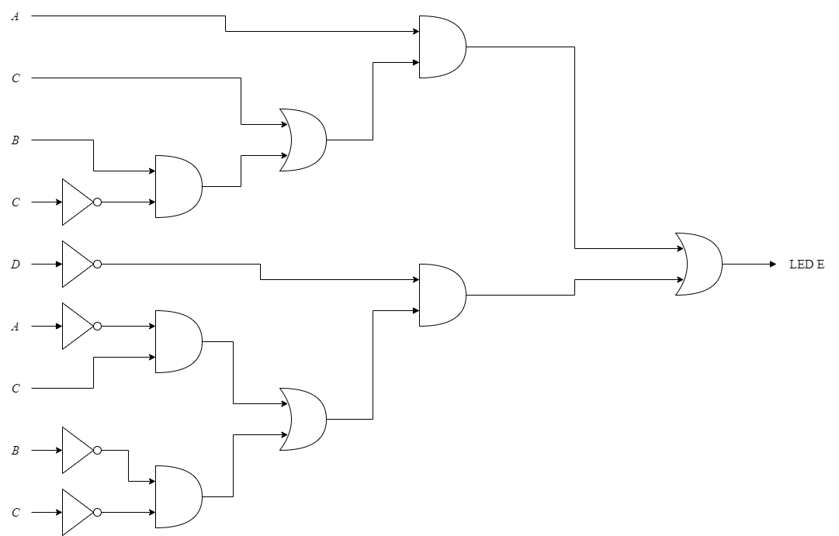

* LED F

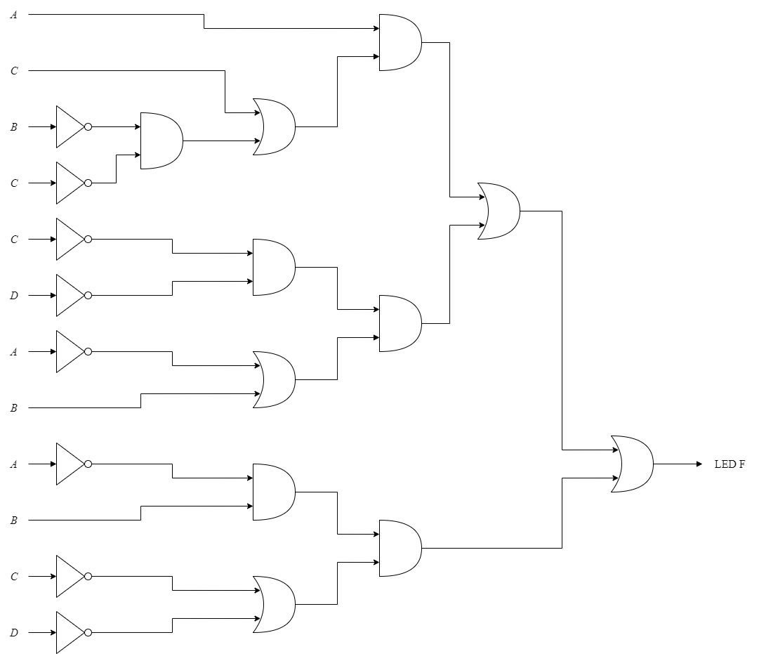

* LED G

